America’s Boating Club – Mid-Atlantic
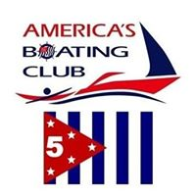
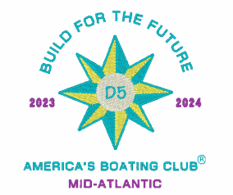
2023 Summer Council
RESERVATION FORM
28-30 July 2023
Lankford Bay Marina, Rock Hall, Maryland

MEMBER: Rank ______ Name ___________________________________________ Grade ____
ADDRESS _______________________________________________________________________
SQUADRON ________________________________ POSITION __________ FIRST TIMER? ______
E-Mail ___________________________________________________ PHONE _________________
SPOUSE/OTHER ATTENDEES:
Rank ___ Name ______________________________________ Grade _____ FIRST TIMER? _____
Rank ___ Name ______________________________________ Grade _____ FIRST TIMER? _____

REGISTRATION FEE # _____ @ $10.00 = $ ___________

SATURDAY ENTRÉE CHOICES:
Chef Zach’s Famous Pulled Pork w/ House Made BBQ Sauce # _____ @ $25.00 = $ ___________
Roast Chicken w/ Garden Grown Herbs # _____ @ $25.00 = $ ___________
Portobello Caprese (grilled Portobello, tomato,
Lettuce, basil mozzarella, with a creamy
Italian Spread – this is a COLD sandwich) # _____ @ $25.00 = $ ___________

Selections served with Garden Fresh Salad, Mac and Cheese, your choice from the Dessert Bar, Lemonade, Tea & Water
Total Enclosed: $ ____________

Dietary Restrictions: ________________________________________________________________

Recommended Dress for Saturday Dinner: Casual

MAKE SLIP RESERVATIONS DIRECTLY WITH MARINA – Call Candy at 410-778-1414. Please mention that you are with Annapolis Sail and Power Squadron to make sure you get one of the reserved slips. Our reserved block of slips expires on June 9.

The slip rate is $2.25 per foot, single electric is $8.00, and double electric is $16.00

Meal Reservations must be received by 13 July 2023!
Make Checks Payable to: ASPS
Send to:
Georgiana Maszczenski
103 Little Neck Road
Stevensville, MD 21666

